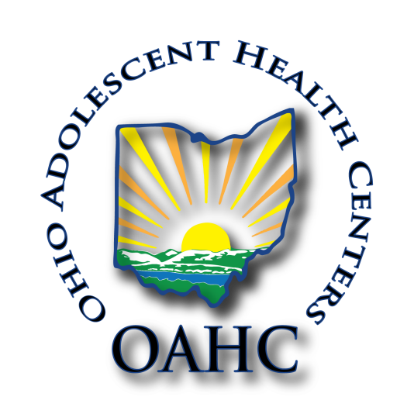
Urgent help needed!
Dear friends:
OAHC is a collaborative of nine organizations who are dedicated to serving Ohio youth in public and private, middle, and high schools with life-saving, life-changing education about healthy relationships, marriage, and family.
OAHC’s goal is optimal health for all, and we address risk behaviors such as sexual activity, alcohol, other drugs, violence including but not limited to bullying, dating violence and human trafficking.
OAHC is in dire straights as our state funding was cut from the Ohio state budget in June, 2023, but also federal funds have decreased this year.
We find ourselves in an urgent situation with more schools scheduled than we have funds to meet. We are in urgent need of $120,000 to help us finish out this school year. Can you help meet that need. Schools are counting on us to be there because we help schools meet the Parent Right to Know Law. If we are not there Planned Parenthood groups will be. They say they meet the law, but they do not. We cannot stand to lose these schools.
Can you help us with any amount?
Please share with like-minded people. We know it takes time, unfortunately we were planning for an increase from federal funds that has not materialized this year.
Please send donations to OAHC which is a 501c3 organization.
You can donate through our website at OAHCyouth.org or mail donations to:
OAHC, PO Box 985, Sunbury, OH 43074
Sincerely,
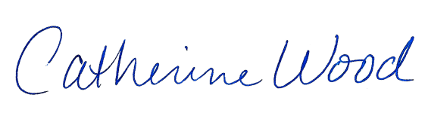
Catherine Wood
President of OAHC

